The i-Save Budgeting & Savings Web Application

INFM498: Informatics Capstone Section: 2WVT

Dedric T. Hill

Student ID: 10988272

Spring Semester 2019

Mercer University

Professor: Feng Liu Ph.D.

# CONTENTS:

Executive Summary

Acknowledgments

Background

Project Planning

Project Development

Usability Study

System Revision

Acquired Application Experience

Conclusion and Future Work

References

# EXECUTIVE SUMMARY

The goal of this research and application is to discover if the presence of an application which tracks a person’s personal expense spending will motivate people to spend less money per month than they would without the usage of such an application. Length of the study group involvement will be from 4-6 weeks. Data will involve the participants’ spending habits prior to their use of the application also. Survey data showed that most respondents have not done any significant saving in the last month. If the research is correct, these habits are inline with most Americans.

The application will allow users to add a record anytime they make a payment into one of their personal expenses such as their mortgage, groceries, travel, clothing, etc. The user will then be able to see their spending from month to month and will be able to see where they had decreases (or increases) to better understand their habits and where they might want to cut back.

Though the study has not ended, this report is used to understand the process and findings in progress.

Acknowledgements

My thanks go out to Dr. Feng Liu for her diligent encouragement, expert advice, and her belief that all her students can perform minor miracles. This project has been intimidating due to our accelerated schedule and our non-university life, but Dr. Liu has provided the needed resources and knowledge to help us push through to the end. Her dedication to her students’ success is a driving force in the Informatics program.

I also give thanks to my study participants who all completed the provided survey in a timely manner. I worked to ensure that the questions were not too intrusive into their personal lives, but anytime that questions of personal money are proposed to a person, a certain level of discomfort is felt. However, my respondents stepped up to assist and provided the needed detailed information for the study. These people include James Hill, Dessie Hall, Mylshia Ford, Crystal Wilson, and Tara Wilkerson.

Additionally, my fellow Mercer classmates and other students took time out of their busy schedules to provide survey answers. These people include Airea Reese, Tamika Chambliss, and Britney Williams. Amid their studies, jobs, family life, Atlanta traffic, and all the other business of life, they were able to assist me in my data-gathering initiative.

Background

According to Brian Collins and Shai Akabas, Americans are not saving enough money for retirement if they are saving at all. In 2017, only 54% of Americans could come up with $400 in an emergency without borrowing or selling possessions. 6 challenges to retirement security are:

1. Nearly half of private sector workers do not contribute to retirement savings plans.
2. Low levels of short-term savings leave people in a bind for emergencies causing them to dip into retirement savings.
3. Americans are living longer and spending more years in retirement but are not preparing for it properly.
4. Home equity is usually the largest form of household savings, but often premature borrowing depletes it early on.
5. Lack of knowledge in financial capability greatly leaves many Americans at a disadvantage.
6. Social Security is significantly underfinanced.

Americans are living longer and spending more years in retirement, but nearly half of private sector workers do not contribute to retirement savings plans (Akabas & Collins, 2017). Megan McArdle reports that the savings of millennials are not too much different from the savings of other Americans. She also notes that income stagnation over the decades has not been proven to be the reason that Americans are not saving (McArdle, 2018). It’s a mystery where their extra money is going. In recognizing this trouble, I decided to find a way to increase people’s focus on their savings habits.

Already, there exists software such as Quicken which "help[s] consumers budget, pay bills and analyze their portfolios". It made getting a grip on their money a little easier for people. While Quicken’s products usually have a cost, many banks and fintech companies have offered paid and free products that simplify people’s personal money tasks. Their products include desktop, tablet, and mobile phone apps (Wisniewski, 2016). There are many other personal finance applications. However, little is known about which consumers use financial software and whether the use of such software results in better financial outcomes. In the past 20 years, there has been a shift of responsibility into the hands of individuals to fund their own retirement income from savings. Additionally, most households have difficulty calculating growth of assets over time. (Bi, Finke, & Huston, 2017).

The software proposed in this report is designed with hopes to fill the gaps which might be left by those existing tools. Users will be able to set a monthly spending limit in several categories of personal expenses. The application will accept data, post to a database, and allow for analysis of that data.

This initial research includes the study of journals, magazine articles, and books on personal finance, retirement savings, and financial software. Further research involved survey of students, colleagues, and other individuals, mostly of middle-class status. The survey was taken between the dates of April 1st and April 11th, 2019. One individual had added $2500 dollars to savings in the 2 weeks prior to taking the survey. However, the others averaged $25.63. This is inline with most of the published research. We must find if easy access to an app such as the proposed i-Save app will prompt people to more closely track their spending, pushing them to spend less and save more.

Project Planning

Methods of conducting the research include:

* Wireframe testing
* Usability testing
* Participant survey
* Participant usage of the application

Stakeholders  
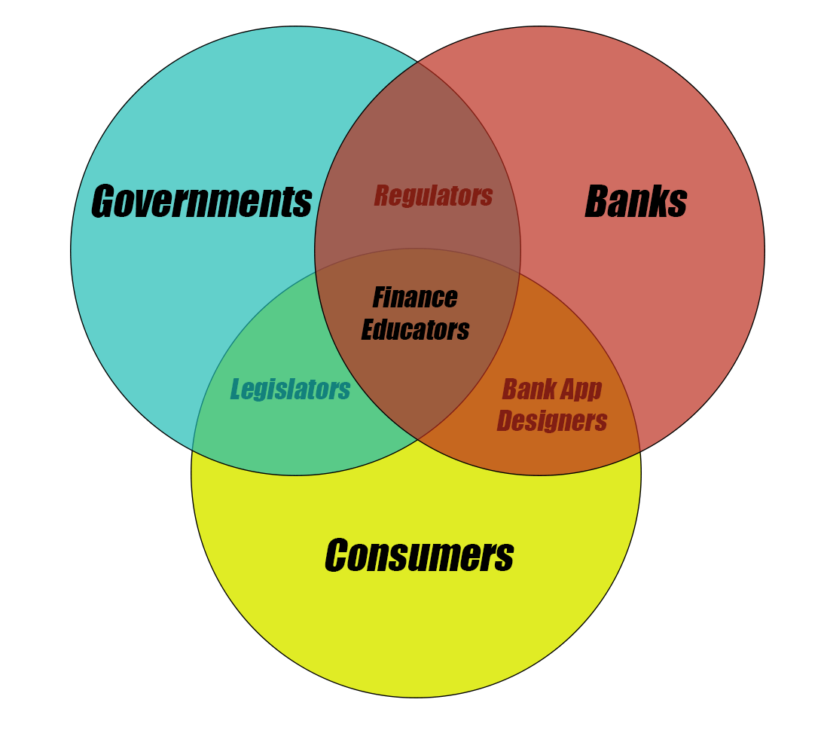

In this map, we see a relationship among:

1. Individual consumers (the people)
2. Banks (suppliers of the most popular savings method: savings accounts)
3. Governments (the city, states, country for whom healthy savings make for financially-secure citizens)

Between consumers and banks, we have those who could help to provide better applications with the goal in mind to help the consumer save more money. This helps the banks to have more money to invest and the consumer in having larger money reserves. Between consumers and governments are legislators who may provide support via programs like social security and Medicare and Medicaid. The government also taxes savings. Thus, higher levels of savings for individuals creates more revenue for governments and less dependency on governments. Between governments and banks are regulators who ensure that banks operate in a manner that is beneficial for consumers and ethically as well. Finance educators may have once been in the banking business or simply be finance PhDs or in similar fields. They can help people in banks, government, and individual consumers to become better at increasing the savings of the consumers and applications such as the one proposed could be part of their teaching.

My design plans for this application have come after many considerations and changes in considerations. These considerations include:

* The app should be easy to use.
* Information should be simple and well-laid out.
* It is not necessary to include bank account information.
* Time restraints

Simplicity and ease of use are necessary. The project was initially slated to take place over an 8-week period ending April 26, 2019.

Wireframes for this application are built using Adobe XD. In past classes, we have used the Balsamiq Mockups 3 application. However, the Balsamiq tool does not apply color to its wireframes. It is also more restricted in its design capabilities. Adobe XD adds color and more design options for more up-to-date appearances in prototyping wireframes.

Ideally, the application will allow the user to enter monthly budget in the form of a dollar amount. This will be entered via text input. After submitting the budget, the user will be able to view their monthly expenses. These include the following:

* Mortgage/Rent
* Home Insurance
* Electricity
* Home Gas
* Groceries
* Child Care
* Restaurants
* Vehicle Loan
* Gasoline
* Telephone and Internet
* Entertainment
* Travel
* Clothing
* Other Expenses

Additionally, several expenses will be considered discretionary. Initially, these will include clothing, entertainment, and restaurants. For these items, users can set a monthly spending limit within the app (clothing is a necessity but planned monthly limits can help in keeping a budget). Once the application is complete, the plan is to have an alert sent to the user whenever the limit is reached for each of the three expenses for which a limit can be set.

Month-to-month decreases (or increases) in spending can be seen on the Expense Savings page as shown here. The user can look at the most recent two months’ expense totals, and whether there was a decrease in spending. Additionally, there is a line item for the total savings from the beginning of the year.

Assumptions based on the survey suggest that the users are aware of their spending habits on their important personal expenses. With this assumption in mind, the expectation is that users will remember to input their payments for these expenses each time a payment is made. A future enhancement may include bimonthly alerts to input payments so that the record remains accurate. This type of alert will be helpful in that many people use automatic recurring payments as opposed to manual payments.

Access into the application will be restricted using username and password technology.

Once a user registers, a profile is created with the user ID being the primary key in the database. Initially, I considered having the user ID be a separate data item from the user’s email address, as shown here. However, simplicity would dictate that the user ID can be the user’s email address.

Task List

1. Sandra and Neal Chung don't know where their money is going. They are always broke at the end of the month. Sandra's friend tells her about the budgeting app after Sandra vents to her. Sandra decides to start using the app. She downloads the app, logs in, and adds two expenses paid over the last two days.
2. Andy Lee needs to save more money over the next few months because he needs a car. He wants to cut back on his expenses and set limits where possible. He decides to set some spending limits on the i-Save App. He chooses to set his clothing limit to $100 per month and his restaurant limit to $130 per month.
3. Warren Raines has no money in his savings account. He uses the app to ensure that he is spending less money each month on his expenses. The app gives him the ability to check his expense savings from the previous month. He decides to check if he saved any money this month compared to last month's spending.

Usability Study

Usability studies of the application will continue in future development of the application. Using the prototype for testing, I was able to have users complete several tasks. In the video located in the following URL, I give the user 3 tasks to complete:

[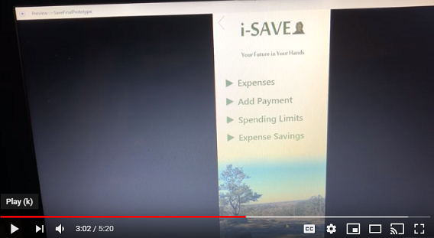](https://www.youtube.com/watch?v=pSd4BfT1WXg&feature=youtu.be)

<https://www.youtube.com/watch?v=pSd4BfT1WXg&feature=youtu.be>

The tasks are inline with those in the task list in the previous section. In this user observation, the user was able to successfully navigate the prototype to complete the tasks. As development continues, this observation and others can be used to better adapt the application to the user’s expectations in behavior and to perfect design for better flow.

Though I began work on the eye checking system, more testing with different users will be needed. The eye checking system will give more clues from the user’s involuntary actions in scanning the application.

Information was also gathered from respondents prior to user testing via emailed survey. Here are the survey questions used:

1. In what age group are you: 20-29, 30-39, 40-49?

2. Choosing the closest option available, what is your gender: male, female, or other?

3. How many children do you currently support financially?

4. Every two weeks, how much money do you put into maintenance and fuel for your vehicle or commute?

5. Every two weeks, how much money do you put into home utility bills?

6. How much money do you as an individual pay into mortgage or rent?

7. How much money did you pay for childcare in the last two weeks?

8. How much money did you personally pay for food in the last two weeks?

9. Do you have a personal savings account (separate from checking)?

10. Do you currently contribute money to a retirement account such as a 401K or IRA?

11. How much money did you add to your personal savings in the last two weeks?

12. How much money did you take from your personal savings in the last two weeks?

13. Do you follow a monthly or weekly budget which you track on paper or computer or mobile device?

14. How many miles do you travel (one way) to your job or business each day?

15. If known, how many miles to the gallon does your primary vehicle that you use to get to work get?

16. Do you currently use a budgeting application on your computer or mobile device?

17. Are you currently saving money for a specific future purchase?

18. If you answered yes to #17, what specific future purchase are you saving for (N/A if not applicable)?

19. How many people (including children) live in the same home as you?

20. How much money do you spend toward pet care and food every two weeks?

System Revision

Previous plans for the app were to include details of a user’s input in to their savings as opposed to how much money they saved month to month in expenses. The initial idea was that when a person spends less on their living expenses, they’d add more money into their banking savings account or other savings. However, at the suggestion of Dr. Liu, I moved away from this direction and focused instead on the amount of money saved by the user when the spend less money per month on their expenses.

Additionally, the later version has updated flow based on input from professor and my own testing. I updated the main menu to include the “Add Payment” option:

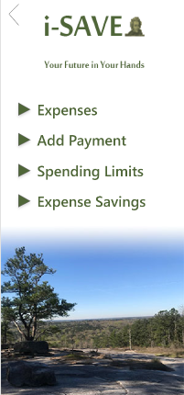

This makes an easier way for the user to more quickly do this task which is likely to be the most common. Then, on the payment screen, I removed the existing limit info to make for a cleaner submission. The previous is on the left and the new view on the right:

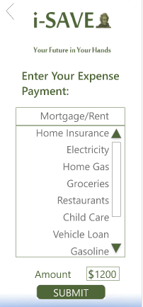

Also, in the new version, the Spending Limit update screen is simplified by removing the view of the existing spending limit from the update screen itself. Once the user updates a spending limit, the screen showing the updated spending limits appears. Below are the two new screens:

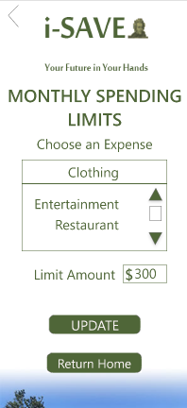 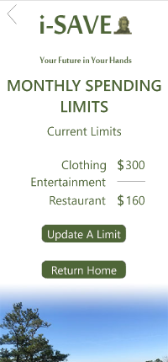

This newest design has a simpler, more intuitive interface. The buttons make sense and the information is clear with the desired information.

Acquired Application Experience

In this research and project work, I learned to work in at least two new applications. The first is through creating the prototype in Adobe XD. It did not take me long to figure out the very intuitive interface. XD allows you to create colorful mockups for different designs fitting computer monitors, tablets, and smartphone screens. There are video tutorials on YouTube which allow for quick ramp-up in effectively using the application. It can be used to create low and high-fidelity designs, plan the flow of applications, draw icons, and other tasks.

For project management, I learned the basics of Gantt charts. Gantt charts are bar charts that illustrate project schedules. These were named after Henry Gantt, who designed such a chart around the years 1910–1915 (Wikipedia, 2019). We used this to set schedules for the tasks at hand for the research, development, and testing of applications. Start and finish dates are clearly illustrated along with task statuses.

In addition to these, we worked with any eye-tracking system which tracks a user’s eye movement as they are using an application or website. The eye-tracking application lets us add surveys to gather information from users during the eye-tracking session. This allows for demographic analysis for a breakdown of how different groups of people use and react to the development. The hardware for the application includes a flat bar, approximately 1 inch in width, ½ inch in height, and 15 inches long, about the length of a laptop. There are three scanners under a dark glass cover. These scanners monitor the movement of a user’s eyes and can create several informative graphs and readouts to give the developer important information about how different parts of the design attract or don’t attract attention. Armed with this info, developers can redesign the interface as needed.

**Conclusion and Future Work**

There is great potential for growth for this application and I hope to share involvement in it to future students. It can become very helpful to many people who may have difficulty gaining access to and finding the time to use other finance tools. We are all aware of the immensity of financial problems that so many people have in their lives. Tools as simple as this can be less intimidating to the average person who may benefit from the usage.

Further development will take place to build off the research and the prototype design. This might include the ability to make more personalize information available to users. More itemized expenses would make for good additions. Also, the ability to export and print details from the application and could be very helpful for a person’s personal accounting.

References

Akabas, S. & Collins, B. D. (2017). Bipartisan recommendations-for policy makers and practitioners-to improve retirement security and personal savings. Benefits Quarterly. Brookfield. 33(3). Retrieved from https://www.ifebp.org/inforequest/ifebp/0200671.pdf

American Express: Microsoft Money 2001 and American Express Financial Advisors help individuals achieve total financial health; American Express Financial Advisors lends expertise to new, holistic approach to personal finance software. (2000). M2 Presswire. Coventry, United Kingdom. Retrieved from https://proxy-s.mercer.edu/login?url=https://search-proquest-com.proxy-s.mercer.edu/docview/445978833?accountid=12381

Appleyard, L. & Dibb, S. (2018). Responsible personal finance: Three fundamental questions. Social Business. 8(1), pp. 57-63. Westburn Publishers Ltd. Coventry, UK.

B.E. Publishing. (2016, May 3). When am I ever going to use this? Retrieved from https://fod-infobase-com.proxy-s.mercer.edu/p_ViewVideo.aspx?xtid=114814

Bi, Q, Finke, M., & Huston, S. J. (2017). Financial software use and retirement savings. Journal of Financial Counseling and Planning; Columbus 28(1).

Duffy, J. (2013). Take control of your personal finances. PC Magazine Digital Edition. Retrieved from <http://web.b.ebscohost.com.proxy-s.mercer.edu/ehost/pdfviewer/pdfviewer?vid=3&sid=7cb623d2-fadd-4601-913c-3d8f02977dc9%40pdc-v-sessmgr03>

Fidelity Study: 'Personal finance' too 'personal' to talk about. (2015, February). Wireless News. Wireless News. Jacksonville.

Kaye, J., McCuistion, M., Gulotta, R., & Shamma, D. A. (2014). Money talks: Tracking personal finances. SIGCHI Conference on Human Factors in Computing Systems. pp 521-530. Toronto, Ontario, Canada.

McArdle, M. (2018, May 22). Why has the personal savings rate declined so dramatically? The Washington Post. Retrieved from https://www.washingtonpost.com/blogs/post-partisan/wp/2018/05/22/why-has-the-personal-savings-rate-declined-so-dramatically/?noredirect=on&utm_term=.30eb86bd8d33

Moreno-Herrero, D., Salas-Velasco, M., & Sánchez-Campillo, J. (2017). Individual pension plans in Spain: how expected change in future income and liquidity constraints shape the behavior of households. Journal of Family and Economic Issues; New York 38(4). pp 596-613.

Netinant, P. & Rukhiran, M. (2017). Aspect-oriented approach for supporting house bookkeeping software design. International Conference on Software and e-Business. pp 49-54. Hong Kong, Hong Kong.

Santhebennur, M. (2017). Personal savings key to retirement. Super Review. Chatswood, Australia.

Schroeder, K. (2003). An interview with Kathy Schroeder: The plot quickens. Ubiquity: Volume 2003 Issue November. Retrieved from <https://ubiquity-acm-org.proxy-s.mercer.edu/article.cfm?id=958080>

Wisniewski, M. (2016). Can a desktop icon compete in a mobile banking world? American Banker; New York, N.Y. 181(224).

Wikipedia. (2019). Gantt chart. Wikipedia The Free Encyclopedia. Retrieved from: <https://en.wikipedia.org/wiki/Gantt_chart>