

Operations Manual

Version2.0

Table of Contents
Basic Operations 3
Users 3
Privileges 3
Application components & functionality 4
Login 4
Logout 4
Register 4
FSR 5
Edit FSR 5
Delete FSR 5
Reset Password 5
Create New Employee 5
Edit Employee Profile 5
Delete Employee Profile 5
Using Software 6
Login 7
Logout 9
Enter FSR(Freight shipment request) 9

Edit FSR(Freight shipment request) 8

Delete FSR(Freight shipment request) 9

Register new employee profile 10
Edit employee profile 10
Delete employee profile 11

Basic Operations

The basic operations of this application are to facilitate the user in their tasks to create, edit, or delete freight shipment requests, and register, update, or cancel client accounts and employee profiles. This application is an employee web portal that is accessible with a valid company email address and password.

Users
The intended users for the web portal are account representatives and the manager, who is by default assigned admin privileges. Below is a list of the different types of privileges given to admin and employee users.

Privileges

Admin privileges:
  - Register new employee profiles
  - Change their password
  - Enter freight shipment requests
  - Create, edit or delete freight shipment requests
  - Create, edit or cancel employee(users) accounts

Employees’ privileges:
  - Change their passwords
  - Enter freight shipment requests
  - Create, edit or delete freight shipment requests

Application Components & Functionality

Login:

This is the access-point for the web portal. All employees who wish to access the portal must do so by way of the company’s website.

All employees must have a valid email address and password to enter into the employee portal. If one or both of these have not been assigned, please contact your human resource representative.

Logout:

This is link is the exit-point for the web portal. All employees must logout all sessions before closing the window.

Do not depend on your session timing out as a form of logging out!

Register:

This link allows new employees to be registered.

Only the site admin can register new employees.

If your session is left idle for over 15 minutes you will have to login back in before trying clicking submit.

FSR (Freight Shipment Request):

This link allows employees and the site admin to submit an fsr for the client.

The fsr will remain in the pending status until the site admin/manager approves the request.

Edit FSR:
      - This link allows the employee and site admin to edit pending fsr.
      - Both the site admin and employee have this privilege.

Delete FSR:
      - This link allows the employee and site admin to delete pending fsr.
      - Both the site admin and employee have this privilege.

Reset Password:

This link allows employees and the site admin to change their password by following sequential instructions.

Both the employee and site admin have this privilege.

Enter New Employee:

This link allows only the site admin to create a new employee profiles.

Only the site admin has this privilege.

Edit Employee Profile:
      - Only the site admin has the privilege to edit employee profile information.

Delete Employee:
      - Only the site admin has the privilege to delete an employee profile.

Using Software
As stated previously this application’s functionality is to facilitate the user in tasks such as creating new client accounts, entering fsr, and generating login credentials for all newly hired account representatives. This section will give detailed instructions on how to complete these tasks efficiently.

Login
Before any tasks are completed, the user must log into the employee web portal. The login page for the employee web portal is accessible through the employee login link in the drop-down navigation list, in the top left corner of S.I.L.A.com. Below are screenshots of the drop-down navigation list:

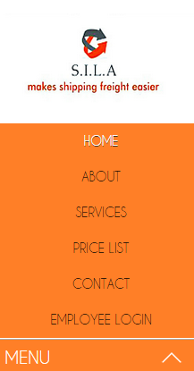
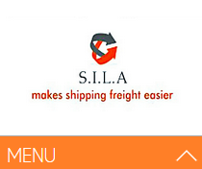

- After clicking on “Menu,” a drop-down list will appear with the links to subsequent pages. Click the “EMPLOYEE LOGIN” link.
  - After clicking on the “EMPLOYEE LOGIN” link, an employee login web page will open asking for your email address and password.
    - USER MUST HAVE A COMPANY EMAIL ADDRESS.
  - Enter in the company provided email address and password.
    - If you are not registered but you do have a company email address then contact your manager.
    - If you do not have a company email address, please contact the appropriate personnel to get one assigned.
    - You must have a company email address to become a registered user.
  - After providing the company “Email Address,” and the assigned “Password,” click “Login.”
    - You must click the login that is below the “Email Address,” and “Password” fields and NOT the one in the right sidebar. The reason for this is that the “Login” that is in the sidebar is the link for this page.
- Below is a screenshot of the employee login page:
  - If the login is, successful and you are granted access into S.I.L.A.com employee web portal, you will then see the homepage of the portal, which will display your name next to “Welcome.”
    - If someone else’s name is displayed here, logout immediately and contact your manager.
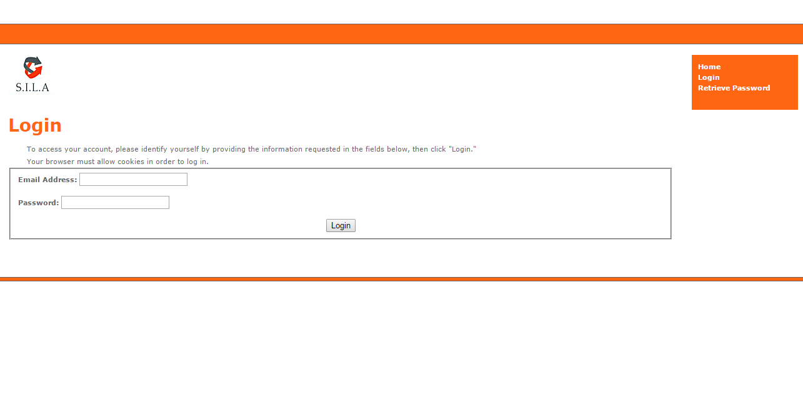

Logout
- In order to logout of your session, click on the “Logout” on the menu.
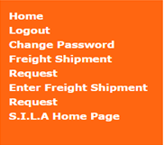

Enter FSR (Freight Shipment Request)
- In order to enter an “FSR,” you must click “Enter Freight Shipment Request” on the menu.

Edit FSR (Freight Shipment Request)
- In order to edit an “FSR,” you must click “Freight Shipment Request” on the menu.

Delete FSR (Freight Shipment Request)
- In order to delete an “FSR,” you must click “Freight Shipment Request” on in in the sidebar.
- Once there you will be able to see a table with all of the pending Freight Shipment Requests.
- Then select “Delete” next to record you wish to delete.
  - A confirmation will confirm that this is the record you wish to delete.
    - A freight shipment request will remain pending until the request has been fulfilled.
    - Once the freight shipment request has been fulfilled the request will be removed from the database by the manager.

Create/Register Employee Profile
- In order to create or register a new employee you must click “Register” on the menu.
- Once there you will be asked for the employee’s first and last name, email address and the password.
  - Once completed an email confirmation with an activation link will be sent to the email previously provided by the employee.
  - The employee must click the activation link in order to activate their login credentials.
  - Once completed the user/employee complete the activation process they can login immediately to access the employee web portal.

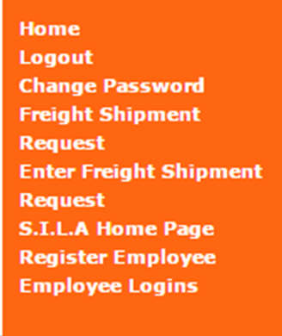

Edit Employee Profile
- In order to edit the employee profile you must click “Employee Logins” on the menu.
- Once there you will see the entire employee login table.
- Select “Edit” by the record you wish to edit.
  - The email address along with the users first and last name will be able to edit by the user.

Delete Employee Profile
- In order to delete the employee profile you must click Employee Logins on the menu.
- Once there you will see the entire employee login table.
- Select delete by the record you wish to delete.
  - You will then see a confirmation, confirming that you want to delete this record, select “Yes” and then “Submit.”
  - If done successfully a confirmation will show telling you that the record was deleted successfully.

